Wireframe

Flight Fare Prediction

Revision Number – 1.2

Last Date of Revision : 27 – 06 -2023

Usama Atta

Document Version Control

Date

Version

Description

Author

27 – 08 - 2023

1.0

Abstract

Introduction

Architecture

Usama

27 – 08 - 2023

1.1

Architectural Design

Usama

27 – 08 - 2023

1.2

Deployment

Unit Test Cases

Usama

Contents

Document Version Control 2

Abstract 4

1. Web Interface

1.1 Landing Page 5

1.2 Predictor Page 5

• User Input

• Result Page

Abstract

The recent changes in the international market had a large impact on the Aviation sector because of several reasons. These impact the two class folks, the first is Business perspective and second is Customer perspective. The major reason for such impact is the governments around the world amended totally different rules to their various Airline firms. Taking these factors into consideration, the value of the flight tickets has varied from one place to another. Booking a flight ticket has its price tag split into two, one is online bookings and other is offline bookings. Each of these have their various criteria for value of the price, one such example is the server load and therefore the range of booking requests. During this machine learning implementation, we are going to see numerous factors that impact the price of the flight ticket and predict the acceptable price of the ticket.

**1. Web Interface**

**1.1 Landing Page**

When the User land on our webpage, they sees a webpage welcoming them to Flight Fare Prediction System

**1.2 Predictor Page**

The user sees various fields asking for information that is required to predict the price of a flight. Every user input has its own dropdown where the user can select their input. After providing the required input and pressing the submit button, the page refreshes and displays the predicted price of the flight.

**2. User Input**

On the predictor page, the user has to provide all the information asked for the prediction. The user can select from the drop down lists attached to each of the input fields. Once all the asked information is provided, the user clicks on submit button to get the output.

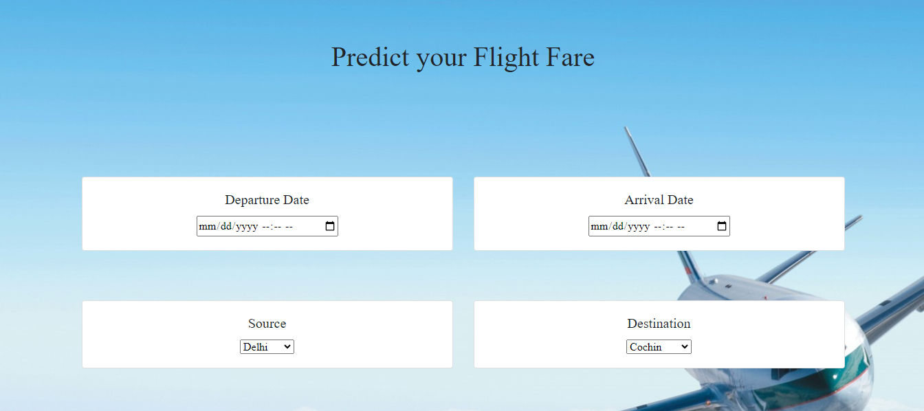

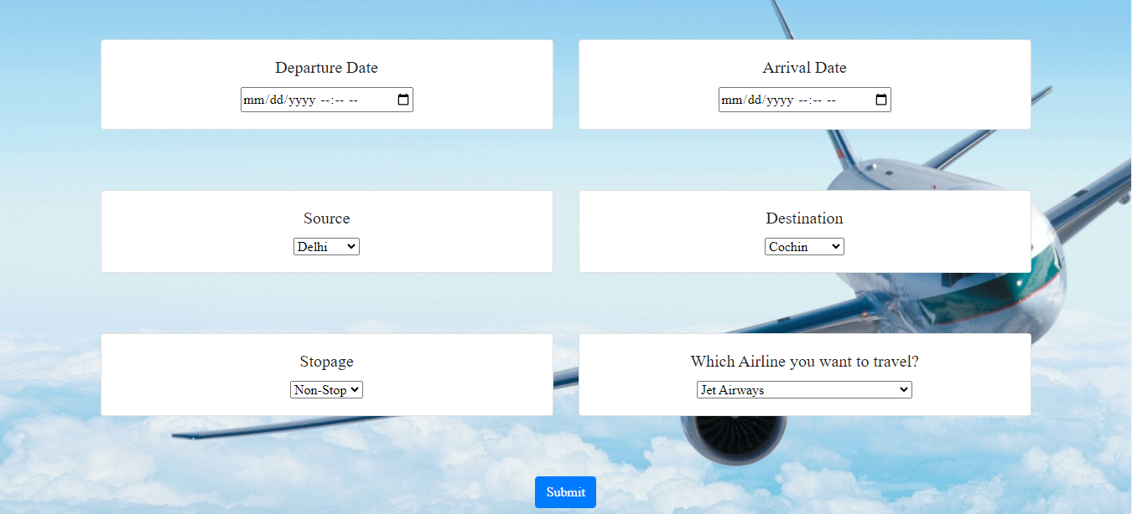

**2. Results Page**

On the predictor page, the user provides all the asked information and then clicks on submit button. The predicted fare of the selected flight is displayed to the user.

